**CHRIST THE KING CATHOLIC PARISH**

**LOCKLEYS**

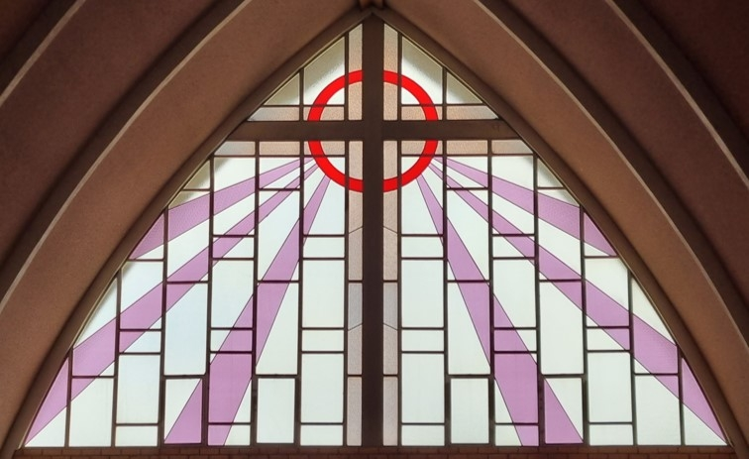

**OUR VISION**

An inclusive and welcoming Catholic community, focussed on Jesus and his mission to the world.

**OUR MISSION**

We accomplish our vision by renewing the faith formation of parishioners, vibrant liturgical celebrations centred on the Sunday Eucharist, pastoral witness and missionary outreach.