Celebrating your Marriage in the Lockleys Catholic Parish Church

As you formally prepare to marry in the Lockleys Parish Church of Christ the King, there are a few things to be aware of that will certainly ease your preparation.
First Steps
- Contact the parish office and ensure that you also contact Fr Michael (if he is the celebrant) to clarify the availability of the Church for the ceremony and, of course, the celebrant.
- Check out here the Government regulations and advice about preparing to get married.
- Download this Form, “Notice of Intended Marriage”, from the website of the South Australian Registrar of Births, Deaths and Marriages.
- Fill out as much as you are able on the first page of the form and bring it with you to your pre-arranged first meeting with the celebrant. Bring also a copy of your birth certificate and a recent copy of your baptism certificate.
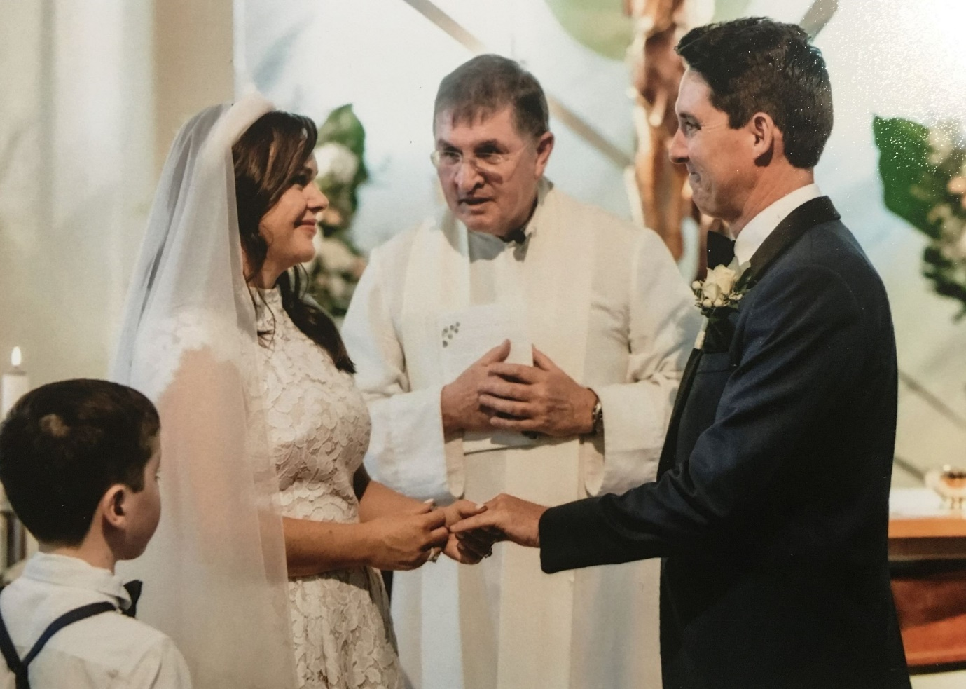
Lockleys’ Parishioners celebrating their Wedding Ceremony
Margo and Nick (with Fr Michael)

Marriage Preparation Meetings
- Fr Michael and a member of the parish’s marriage preparation team will meet with you, work through the necessary Government and Church paperwork, reflect with you on the meaning of the Sacrament of Marriage and spiritually prepare you for the wedding ceremony.
- This preparation will take place over three or four meetings, each for about an hour.
- These meetings are easy and relaxed.
- An important part of these meetings is to reflect upon and decide how you would like to celebrate your wedding ceremony. Work through the
- During this time of preparation, you will be invited to join one of the Sunday worshipping communities (Saturday 6pm; Sunday 9am) to allow them to meet you and pray for you.

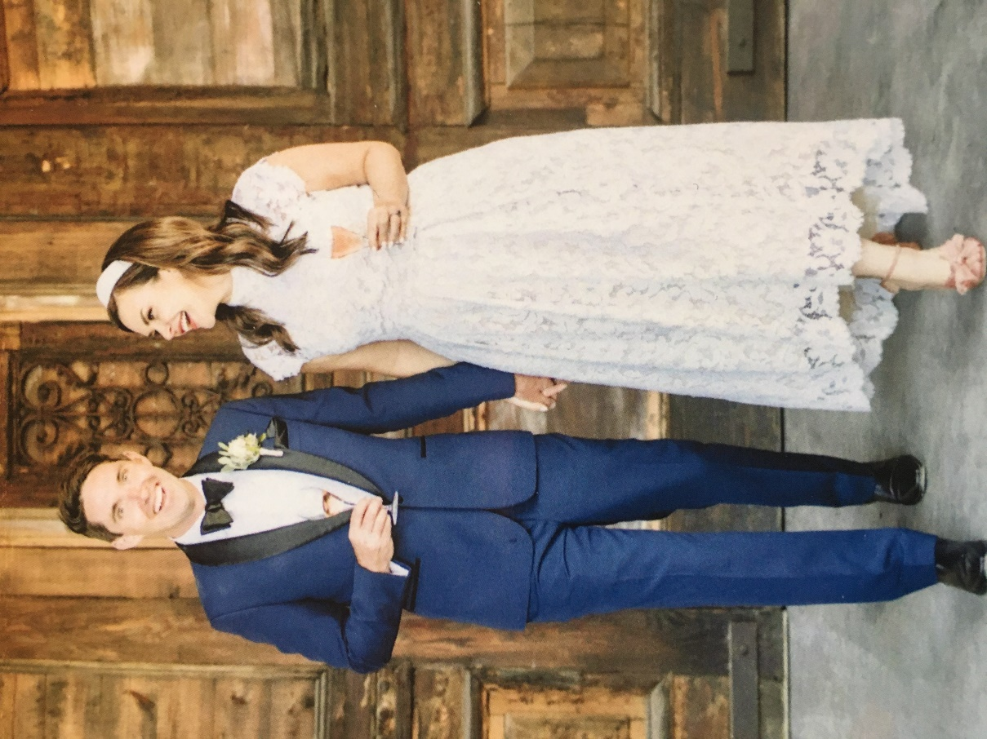
The Newly Married Happy Couple from the Lockleys Catholic Parish, South Australia
Margo and Nick

As the Ceremony Draws Closer

- As time moves closer to the wedding ceremony, you might like to arrange a brief marriage practice. This will occur at the parish church 5.25pm on a Saturday afternoon.
- You and your fiancé (and your wedding party) will be invited to stay for the celebration of the Sunday Eucharist that Saturday.
- This will provide an opportunity for you to spiritually calm yourself as the big day approaches and invite God to accompany you in these final days as the excitement (and tension?) mounts.
- Gathering with the Saturday night worshipping community also provides a moment for it to pray and bless you for your future married life. Your wedding is a celebration of the whole of our parish. Everyone in the parish would like to be part of it!

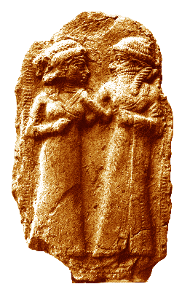

Ancient Sumerian depiction of the marriage of Inanna and Dumuzid
https://commons.wikimedia.org/wiki/File:Marriage_of_Inanna_and_Dumuzi.png

Fees
- There are two fees that you will need to be aware of:
The first is the $300 clergy fee. This goes to a common fund in the Archdiocese and provides a stipend for our clergy. A personal monetary gift to the celebrant over and above the $300 clergy fee is never expected.
The second is the parish church fee of $300. This covers the costs associated with the use of the church building and those who assist in preparing the necessary documentation for your marriage.
- A deposit of $150 for the church fee should be paid at the time of confirmation of the booking, with the remaining $150 and the $300 clergy fee to be paid at least one month before the wedding date.
- If your celebrant is a visiting priest there will also be a separate fee for opening and closing the church – this could be between $50 and $100, depending on whether an additional opening is needed for church decorating, flowers, etc. This needs to be discussed with the parish office staff.
- Payment may be made at the parish office, or if you prefer to transfer the payment online please contact the parish for the banking details.

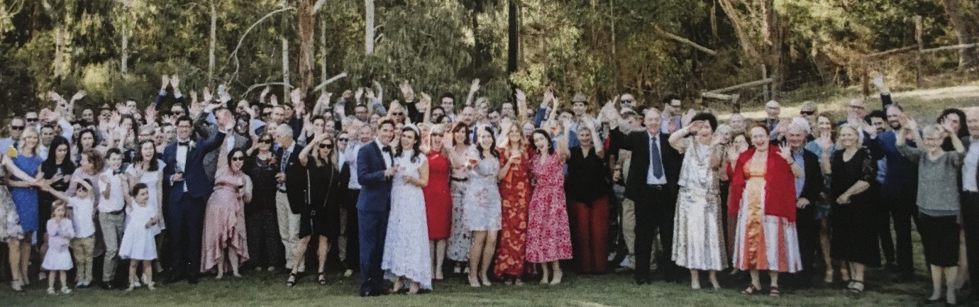
Margo and Nick celebrate with family and friends after their Marriage Ceremony

